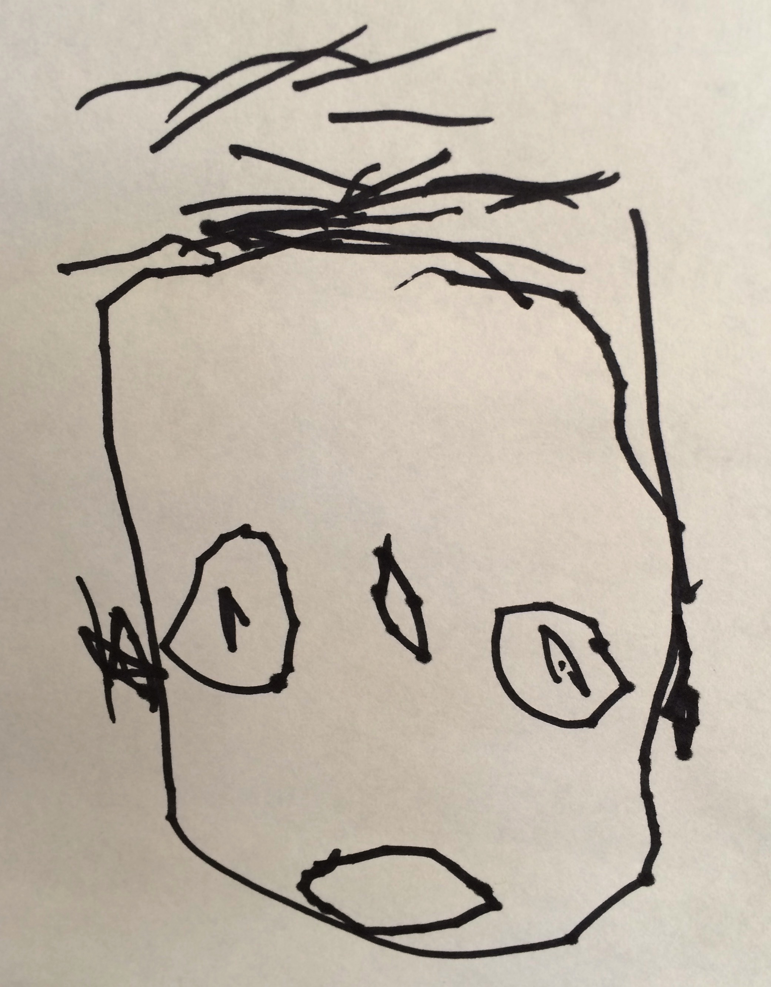
Collaborative Teachers Institute
February 11, 2016
4:30-7:30 pm
I. View Environments Video from Opal School

II. Reflect on Environments Values from last meeting

III. Share Documentation from Environment Study:
Juliet Staveley

IV. Discuss “Making Sense of Play” Exhibit
Share ideas regarding documentation panels

V. Share Documentation from Materials Study:
Suzanne Shakespeare and Aurora Wingard

