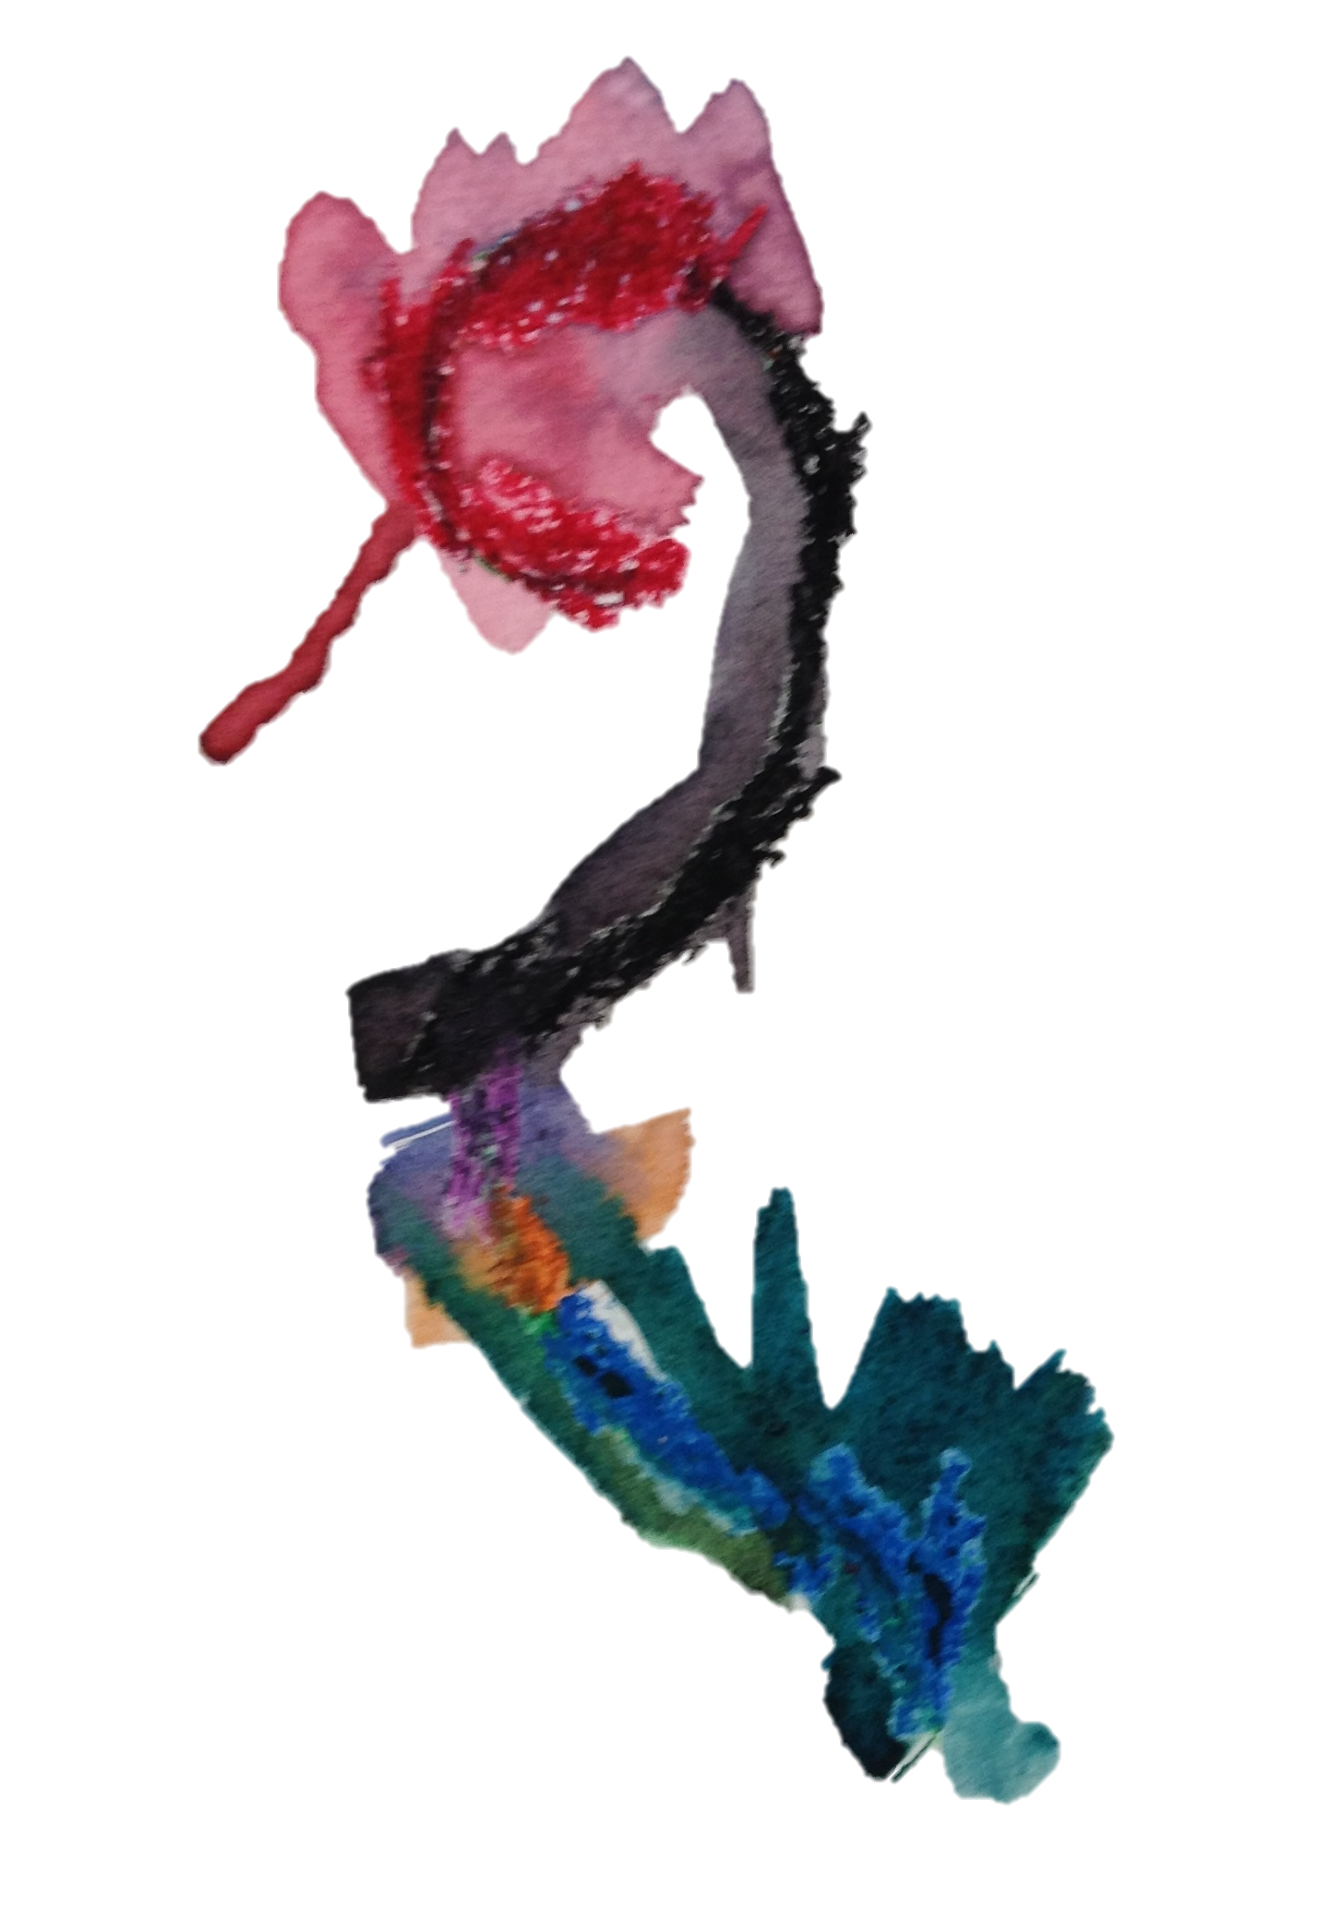
CTI Agenda,
March 22, 2016, 4:30 – 7:30 pm
Santa Fe School for the Arts
Creating Curriculum from Children’s Interests

I. Introductions and overview of readings

II. What does it mean to plan and study with children’s interests?

a. Share ideas from Boston Public School’s early childhood program

b. Documentation and the study of children’s interests

c. Inquiry into Wild Animals from Opal School (video)

III. Teacher Sharing: TBD

IV. All Group Discussion and Sharing for the “Making Sense of Play” exhibit

Readings:
: Mara Krechevsky , Ben Mardell & Angela N. Romans (2014) Engaging City Hall: Children as Citizens, The New Educator, 10:1, 10-20,

Edwards, C.P. & Springate, K. (1993). Inviting children into project work. Dimensions of Early Childhood, 22(1),9-12-40.

Blog Post: http://tajaltspace.com/studying-childrens-interests/

