Agenda Collaborative Teachers Institute 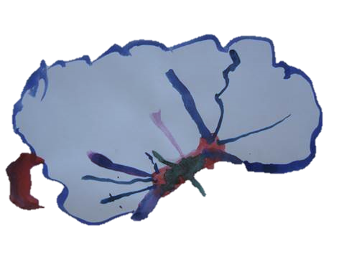
May 17, 2016, 4:00 – 7:00 pm

I. Exhibit updates

II. What is a pedagogical leader? Gigi Yu

III. Exploring Expressive Languages: Kim Shakespeare Jones

IV. Evaluation: Kersti Tyson

