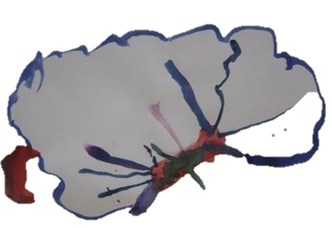
Collaborative Teachers Institute
April 19, 2016, 4:30 – 7:30 pm

- Large Group Sharing: Santa Fe School for the Arts: Paint Brush Panel

- Small Group Sharing: Documentation for Panels

- Pedagogical Leadership: what do we know now?

