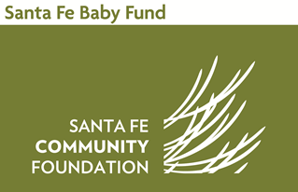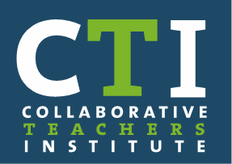

Agenda
Collaborative Teachers Institute
May 3, 2017

I. 4:30 – 5:00 pm Dinner and Updates
II. 5:00 – 5:45 pm How are values communicated through the classroom environment?
Slides from Tucson Head Start and California Programs
Problem Solving Areas of the Classroom (large and small group conversation)
III. 5:45 – 6:30 pm Juliet Stavely – Story from the Classroom
IV. 6:30 – 7:00 pm Reflections on Meeting and Plans for Next Meeting

CTI Task Force Meeting, May 22, 2017

