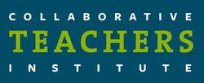

Agenda

March 30, 2017
4:30 – 7:00 pm

Santa Fe School for the Arts

I. Gather and Tour School and Reflect on Reading
Reflect on NMAEYC Conference

II. Sharing Documentation:

Kim Jones – Webster University Pedagogical Coordinator masters degree project

Jennifer Sallee – Outdoor Playground Project

III. Task Force Discussion
Gigi Yu – Shared Services Conference

How does the CTI support assessments you use? Child outcomes?
How is the CTI supporting your work with teachers in your programs?

Plans for April Meeting
Final Reflections

